Welcome a refugee household to your community
You may have seen recent news coverage of the first community-sponsored refugee families being welcomed to Australia by their community supporter groups.

If you’ve ever felt overwhelmed at the scale of the global refugee situation, this is your chance to help - one family at a time. Get involved and experience the joy and satisfaction of working with others in your local community to change a family’s life.

How does it work?

The new national ‘community sponsorship’ program, introduced by the federal government, is based on the popular 40-year-old Canadian model that has seen more than 325,000 refugees rebuild their lives in Canada.

Under this model, locals form a group to welcome a refugee household to their area and provide support over the next year. The group meets the new arrivals at the airport and helps them settle into their new home and community. These volunteers raise a modest budget to help with income support for the first couple of weeks, household furniture and temporary accommodation; but refugees can work and have access to Centrelink support, Medicare and other mainstream government services.
Ongoing support might include help with school or university applications, setting up bank accounts, driving lessons or introducing the new arrivals to a local business that is looking for staff.
CRISP overview

The new Community Refugee Integration and Settlement Pilot (or ‘CRISP’ program) is the outcome of years of research and advocacy.

The program is being delivered by Community Refugee Sponsorship Australia (CRSA) and will support 1,500 refugees referred by the UNHCR to the Australian government for resettlement between now and 2025. CRSA has tested this approach over the last two years, helping people already in Australia. Volunteers say they’ve loved the challenge, often saying it’s the most satisfying thing they’ve ever done, and some already signing up to support a second family.

In a positive development, the Albanese Government has plans to make the places additional to the current refugee quota in the future. Once that has been put into effect, the efforts of everyday Australians will boost Australia’s overall refugee intake as well as offering a warm and personal reception.
The CRISP story so far
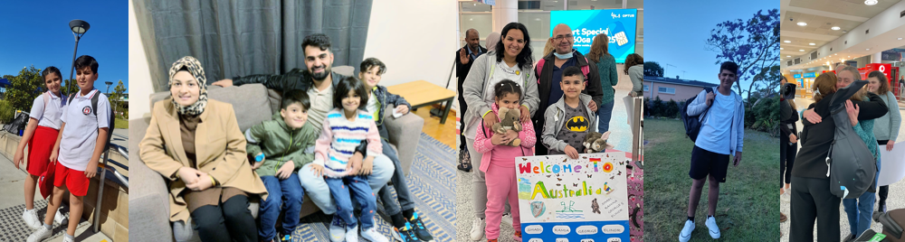
The CRSA team has been inundated with beautiful stories from the volunteer groups as the new arrivals settle in:
“The children - none of whom have had any schooling before - have started school. Meanwhile their parents, who are preliterate, have enrolled in English classes at the local TAFE.”
“ Elya* got her drivers' licence - a huge milestone in achieving independence as her husband Alan* (who, until now, was the only one who could drive) is working as a chef. He's been embraced at work, and the group (who are all mums) are supporting Elya to invest in herself while her young kids are in school and childcare. She's taking swimming lessons and learning to drive. The family are settling well into the local area and is a great match for the group.”

“It was a joy to take the kids to school on the first day! Their mum had been running a makeshift school in the camp so they’d had some basic education, but this was their first proper school day. They were apprehensive but felt much better after a warm welcome from the school.”

* names changed for privacy

An opportunity for regional and metropolitan areas

The program is driven by local demand, as members of a local community instigate the process of inviting a refugee family to come and live in their local area. The group can be located anywhere in Australia: regional and rural communities can welcome new arrivals as well as their city cousins. This is a great opportunity for communities wishing to boost their populations or workforces.

Interested?

CRSA is inviting people across Australia to participate. Local groups of five or more adults can put their hands up to welcome new refugees from overseas. Local clubs, businesses and faith groups can encourage groups to form and support their important work in a variety of ways.

Find out more:
- Watch a two-minute video about welcoming refugees
- Read about the CRISP program on CRSA’s website
- Watch the 35-minute recorded information session to find out more

Apply to be involved:

- Formed a group? Fill in the Group intention to apply form
- Still looking for a group? Fill in the Individual expression of interest form to put yourself on our radar then check out 5 tips for forming a group or head over to our Find a group Facebook page to find like-minded people from your area.

